Forest School at Tighnabruaich Primary and ELCC

Forest School is delivered annually from Nursery to P7 between October and May (to avoid the midgie season). It forms the basis of our Health & Well-being Curriculum, focusing on social and emotional HWB, much of our Language curriculum (Listening and Talking as well as providing a context for writing across the genres) and supports the development of the Four Capacities that the Curriculum for Excellence is built upon – Successful Learners, Confident Individuals, Responsible Citizens and Effective Contributors.
In session 2019/20 sessions will be held on Tuesdays as follows.
AM
P3-4 and P5-7
PM
P1-2
Nursery will have woodland sessions at various points during the week, rather than being restricted to just one session.

On Tuesdays, if your child’s session is in the morning, forest school clothes should be worn to school and school uniform brought in a bag to change into afterwards. Spare underwear and socks should also be brought.
If your child is at Forest School in the afternoon, school uniform should be worn and old, forest school clothes be brought in a bag to change into at lunch time.

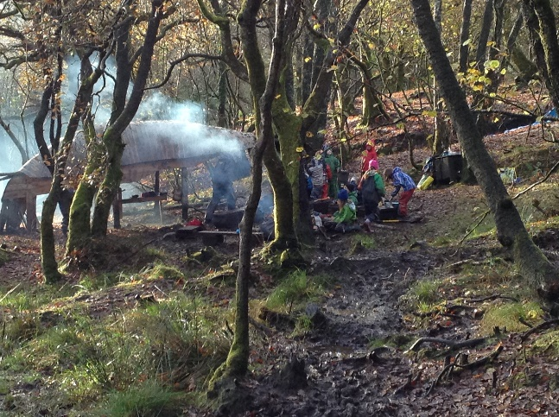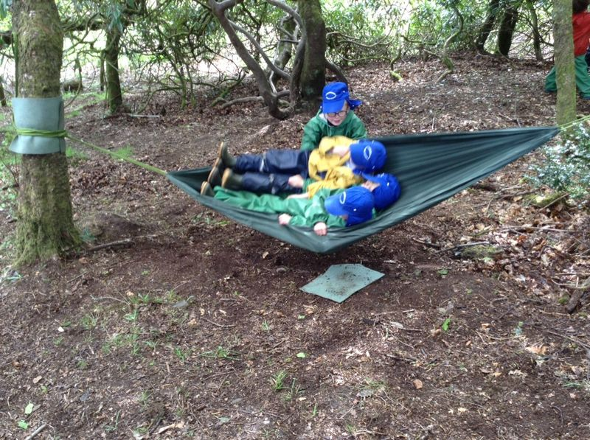
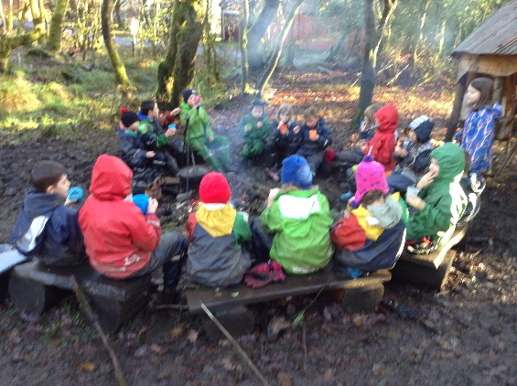

What does a forest school session look like?
Sessions for P1-2, will usually be led by Mrs Hamilton and last approximately 1.5 hours. The structure of sessions is generally as follows:
- Team game (to familiarise with environment and develop team-building skills)
- Risk assessing
- Group special spot & Veil of silence(no speaking once ‘veil’ is drawn down until it is raised again, sitting quietly using all senses)
- Free play (including option of an adult-led activity, such as weaving, peeling sticks, using fire-steels)
- Snack time, developing talking and listening through story-telling.
- Free play
- Gather to review the session & return to school for lunch

Sessions for P3-4, will usually be led by Mrs Stirling and last approximately 3 hours.
- Risk assessing
- Individual special spot & veil of silence (sitting quietly using all senses) followed by group discussion
- Team game (to familiarise with environment and develop team-building skills)
- Free play (including the option of an adult-led activity, involving craft and/or introducing more tool use and fire building)
- Snack time, developing talking and listening,
- Free play
- Gather to review the session & return to school

Sessions for P5-7 will usually be led by Mrs Hamilton and last approximately 3 hours
- Team challenge (to develop team-building & problem-solving skills)
- Risk assessing
- Individual special spot & veil of silence (with given relaxation and observing task) followed by group discussion
- Free play (including choosing an adult-led activity, involving craft and/or introducing more tool use and fire building). During this time one group will have responsibility for getting fire set and started, another for preparing food for sharing and another for setting up slack-line and other equipment.
- Snack time, developing talking and listening,
- Free play as before, including cooking (2 groups.) Specific skill development activity. (1 group). Rotated throughout the sessions.
- Gather to review the session & share food before returning to school.

What to wear for forest school?
Waterproofs, gloves and wellies are provided by school, but children are welcome to provide their own. The following is what should be brought from home for every Forest School session.
Feet: one thin pair of socks with a thicker pair on top. (Wellies, if you’d prefer to provide your own)
Legs and bottom half: two layers if possible. Tights/long socks and warm, comfortable trousers (joggers are ideal)
Top: three layers: Vest/t-shirt, long-sleeved thin top, fleece or sweatshirt
Hands: gloves or mittens (not woollen)
Head: Hat.
Why do we do what we do?
Before any learning can take place, all basic needs require to be met (Maslow’s Hierarchy of Needs);
Basic needs
Physiological:
- Food (snack provided)
- Water (hot drinks provided)
- Warmth (adequate clothing, fire if appropriate)
- Rest (free play)
Safety needs
- Being safe (risk assessments)
- Feeling secure (clear boundaries – physical environment and behaviour)
Psychological needs
Sense of belonging
- Group forming activities
Sense of Esteem
- Learning new skills, achieving personal goals
Self-fulfilment needs
Self actualisation
- Realising individual’s full potential
- Creating
- Developing self-motivation

To find out more about Forest School you are more than welcome to come and join in a session or, visit
https://www.owlscotland.org/local-options/forest-schools/

